**OOP ASSIGNMENT**



**Session 2022 – 2026**

**Submitted by:**

Tayyaba Afzal 2022-CS-134

**Supervised by:**

Dr. Awai s Hassan

Department of Computer Science

**University of Engineering and Technology**

**Lahore Pakistan**

**Problems and Issues with Procedural Programming**

# Disjoint Behavior:

Record of all users are highly corelated, but it is stored in different disjoint arrays and linked with the index number only.

* **Application**

There are four users of my application, and all have disjoint behavior.

**For Login:**

**For Donator:**

**For Need Base Taker:**

**For Merit Base Taker:**

* **Game**

**Example 01:** Here, is the same problem for the game.

**Example 02:** Movement Variables for each action were stored in different variables which increased the disjoint behavior.

1. **Extending The Functionalities:**

* **Application**

**Example 01:** This code only adds the donator add the most least index in arrays. But if we want to add some donator at another index, we must write the change code.

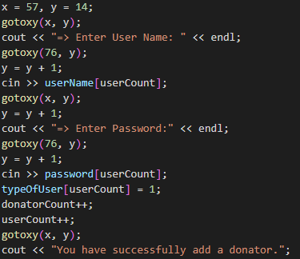

**Example 02:** This Function changes the remove donator from array at specific index. However, let’s say we want to remove all donators we have to write the different code.

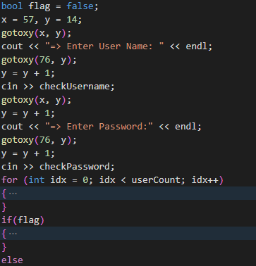

* **Game**

**Example 01:** This Function only moves Nick left. But if we want to move it any other direction, we have to write the change code.

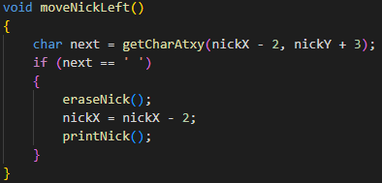

**Example 02:** This Function moves the Nick downward until it comes to ground. If we want to do same means move Nick upward until surface appear then we must write another code.

# Complete Access of Arrays:

* **Application**

**Example 01:** This function accesses the whole array of donator for view data. However, only selective portion of array should be accessible by each donator.

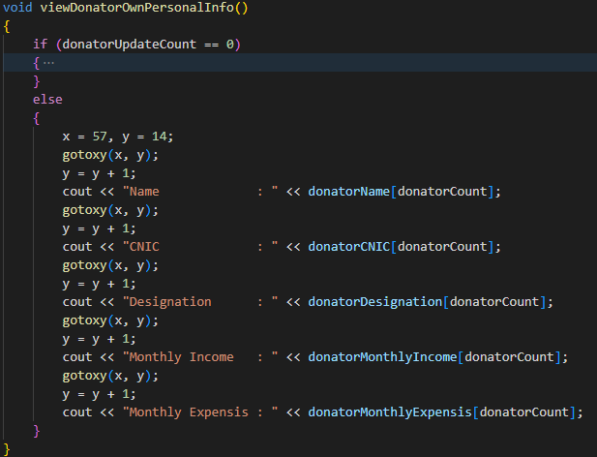

**Example 02:** This function check and show the eligibility of donator but this function also accesses the whole array.

